# **EXPERIMENT-9**

## **VIEW,INDEX,SEQUENCE**

**VIEW**

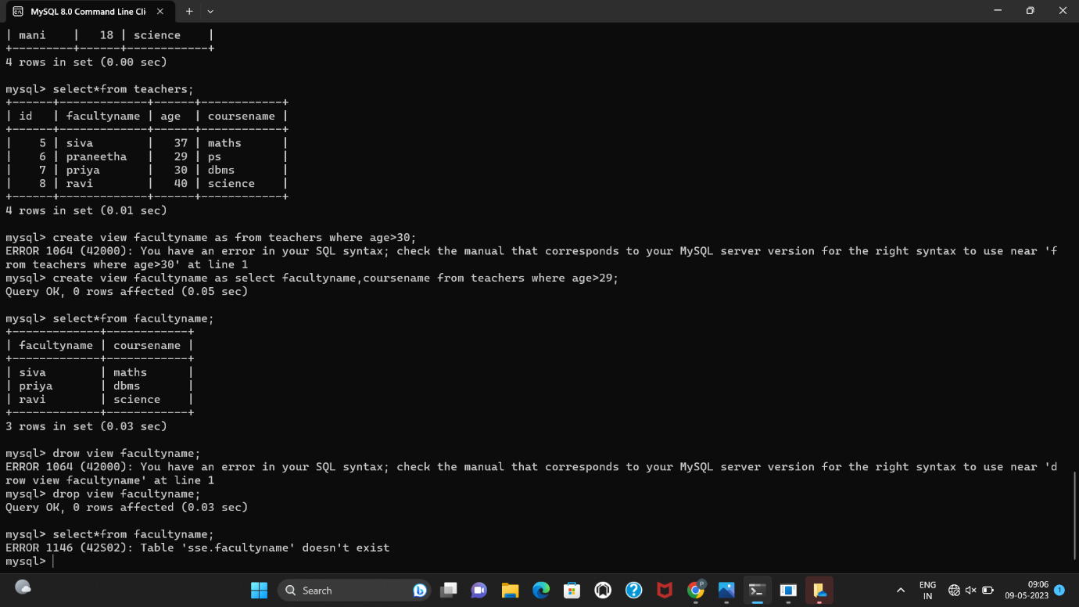

**INDEX**

